Aircraft configurations:

overall config.: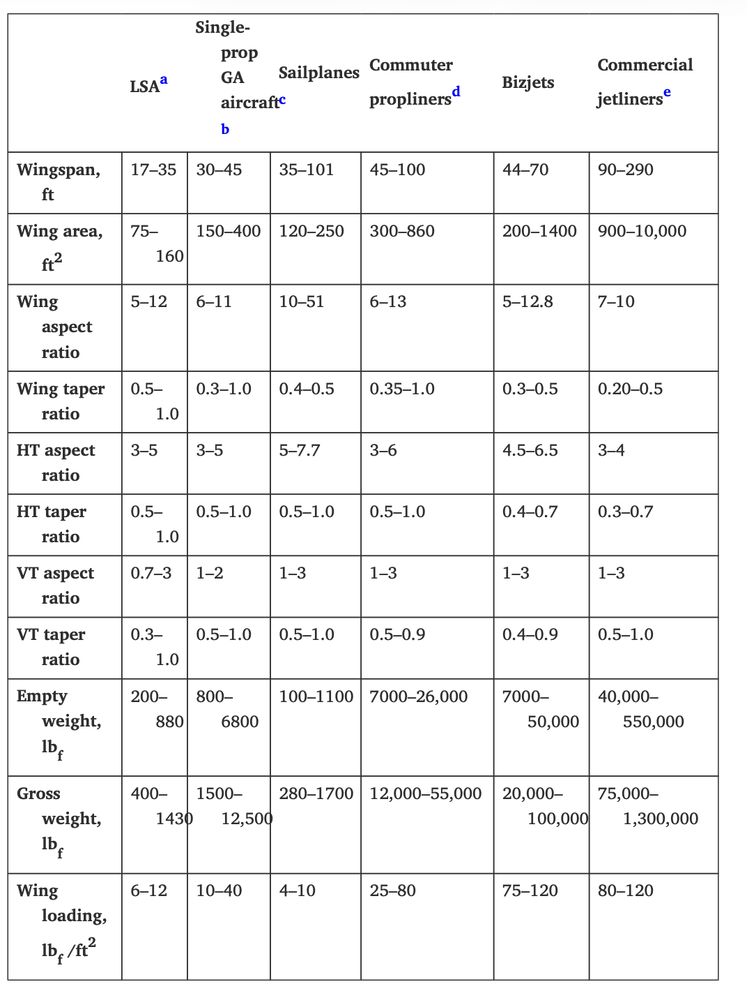
look at wingspan & weight!!

LSA:
at the very extreme, too risky. (weight and span)
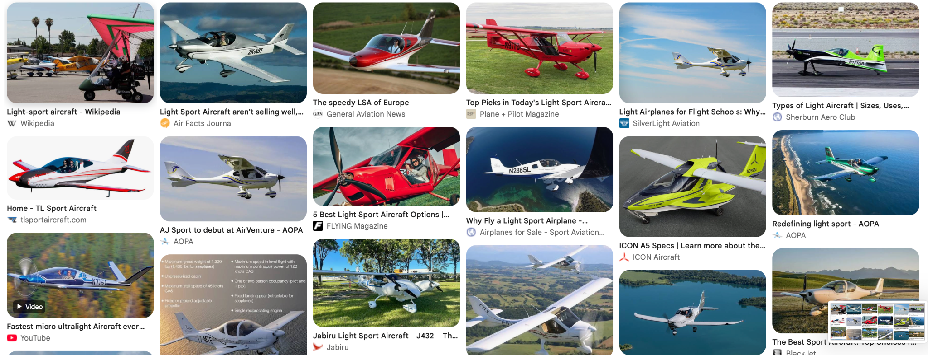

single propeller GA aircraft:

very safe (perfect span and lots of leeway for weight)

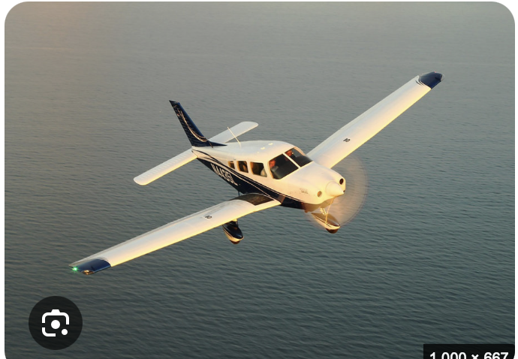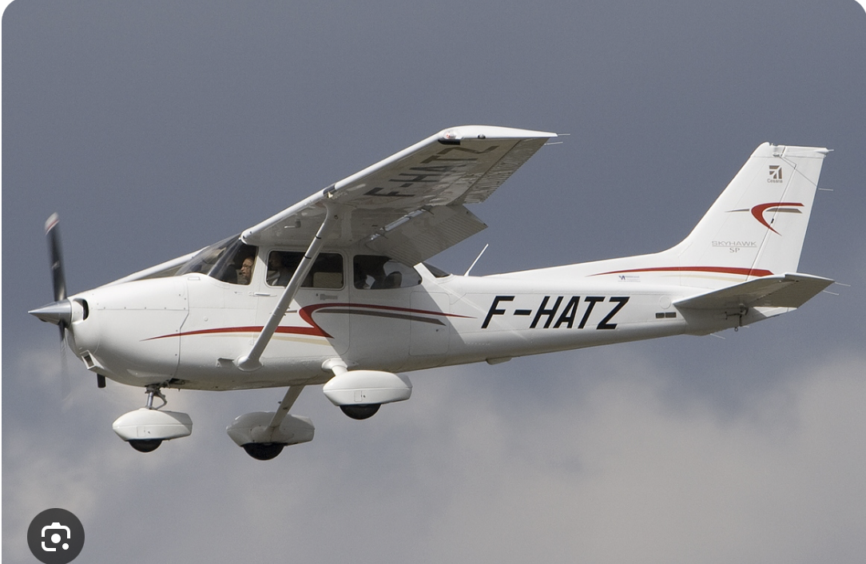

sailplane:

span>> & not enough weight

all others:

overkill, huge payload

wing location:

coeff |  | low wing | mid wing | high wing
3 | fuel feeding system | 1 (need pump) | 2 | 3 (gravity fed)
6 | ground effect | 3 | 2 | 1
4 | best for heavy transport | 3 | 1 | 2 (need anhedral)
2 | least fairring challenges | 2 | 3 | 1
5 | maneuvrability | 2 (need dihedral) | 3 | 1
1 | aesthetics ;) | 1 | 3 | 2
21 |  | 48 | 46 | 32

→ low wing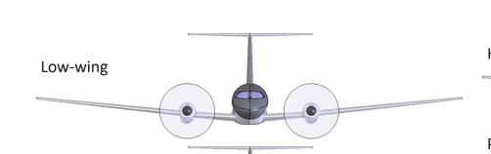

→ wing dihedral for maneuvrability

→ contributes to C_l(beta)

# of wings:

sesquiplane: for crop dusting cus spreads the fluid with 4 vortices if we use water
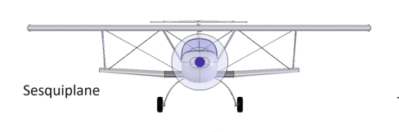

triplane: too complex (novelty)

coeff |  | monoplane | biplane
2 | efficiency | 2 | 1
3 | wingspan | 1 | 2
1 | maneuverability | 1 | 2
4 | simplicity | 2 | 1
10 |  | 16 | 14

→ monoplane

BUT!!! could do biplane if you’re hyped for it

wing structure:

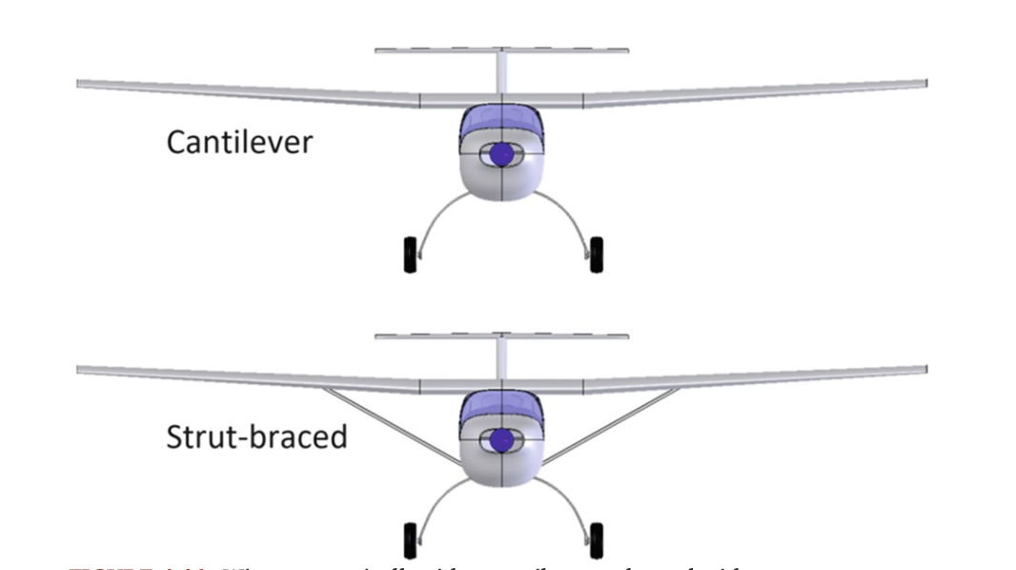

coeff |  | cantilever | strut-braced
1 | aesthetic | 2 | 1
3 | novelty | 2 | 1
2 | efficiency | 2 | 1
4 | feasibility (material & manufacturing) | 1 | 2
10 |  | 16 | 10

→ cantilever wing

Propeller configuration:
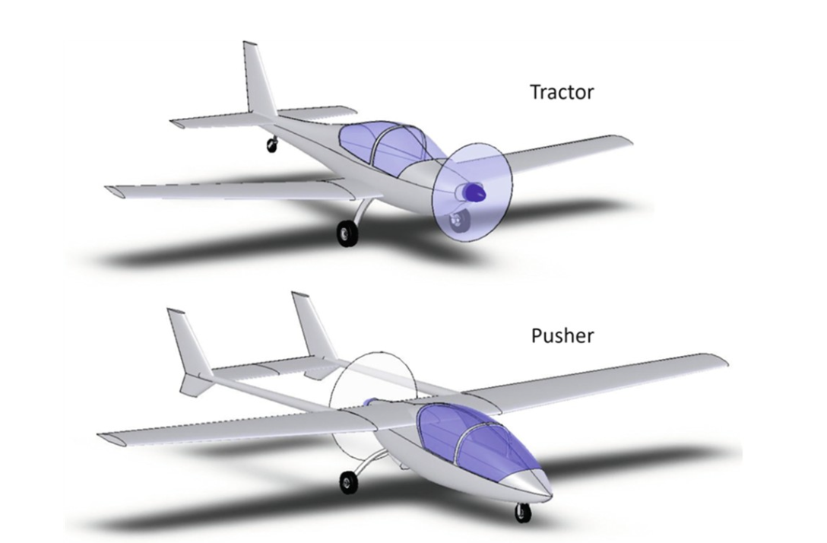

coeff |  | tractor | pusher
1 | observation ability | 1 | 2
2 | novelty | 2 | 1
3 | propeller efficiency | 2 | 1
6 |  | 11 | 7
→ tractor

engine placement:

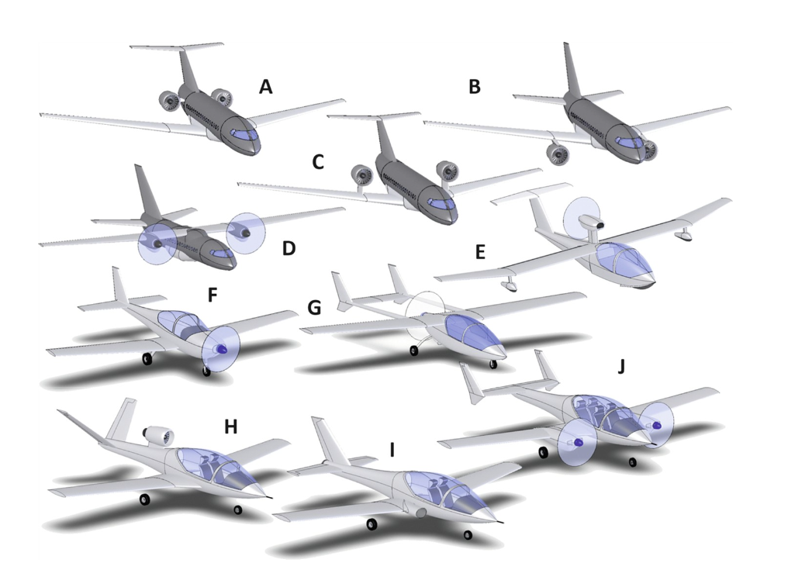
simply taking into account the most conventional placement and limiting the pitching moment by having delta_z ≈ 0.
→ F
→ can align T vector vector c.g. to limit pitching moment

landing gear config.:
only look at 2 most common: tail dragger and tricycle for simplicity
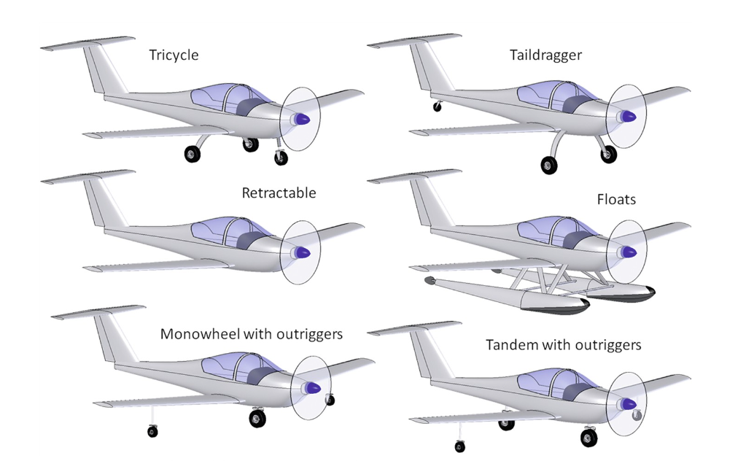

coeff |  | tail dragger | tricycle
2 | drag | 2 | 1
3 | weight | 2 | 1
5 | most adaptable for runways (AOA) | 2 | 1
4 | stability (risk for ground loop) | 1 | 2
1 | novelty | 1 | 2
15 |  | 25 | 20

→ taildragger

Tail config.:
→ conventional tail

because there’s no special requirements, and nothing preventing from using it (simplicity and effectiveness)